1. Install Terraform on your PC

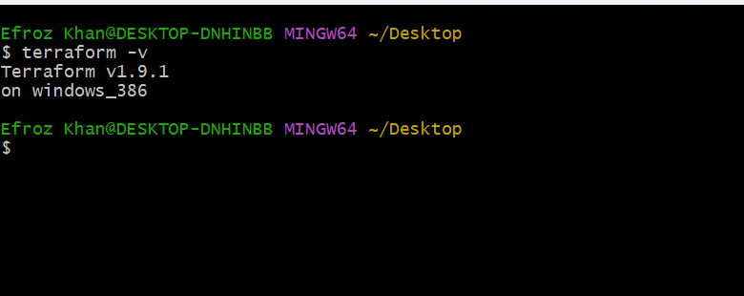

1. Execute all the templates shown in video.

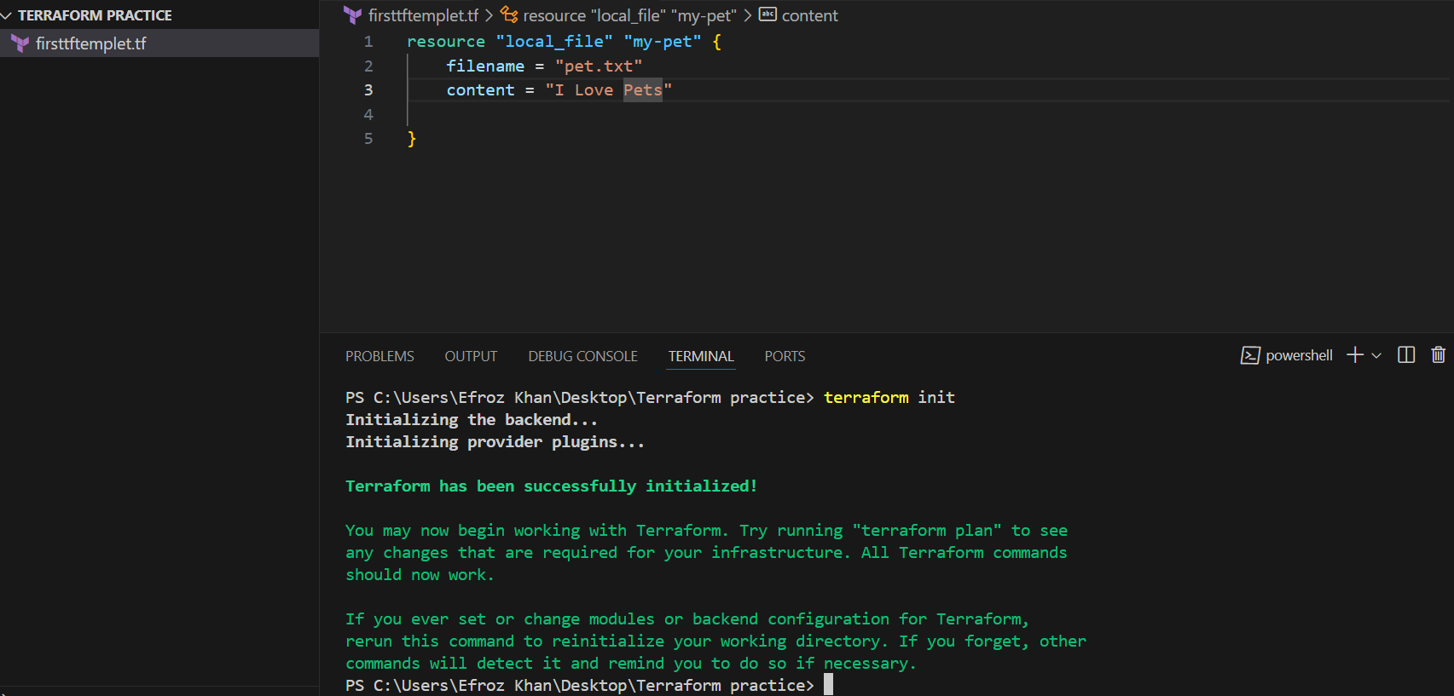

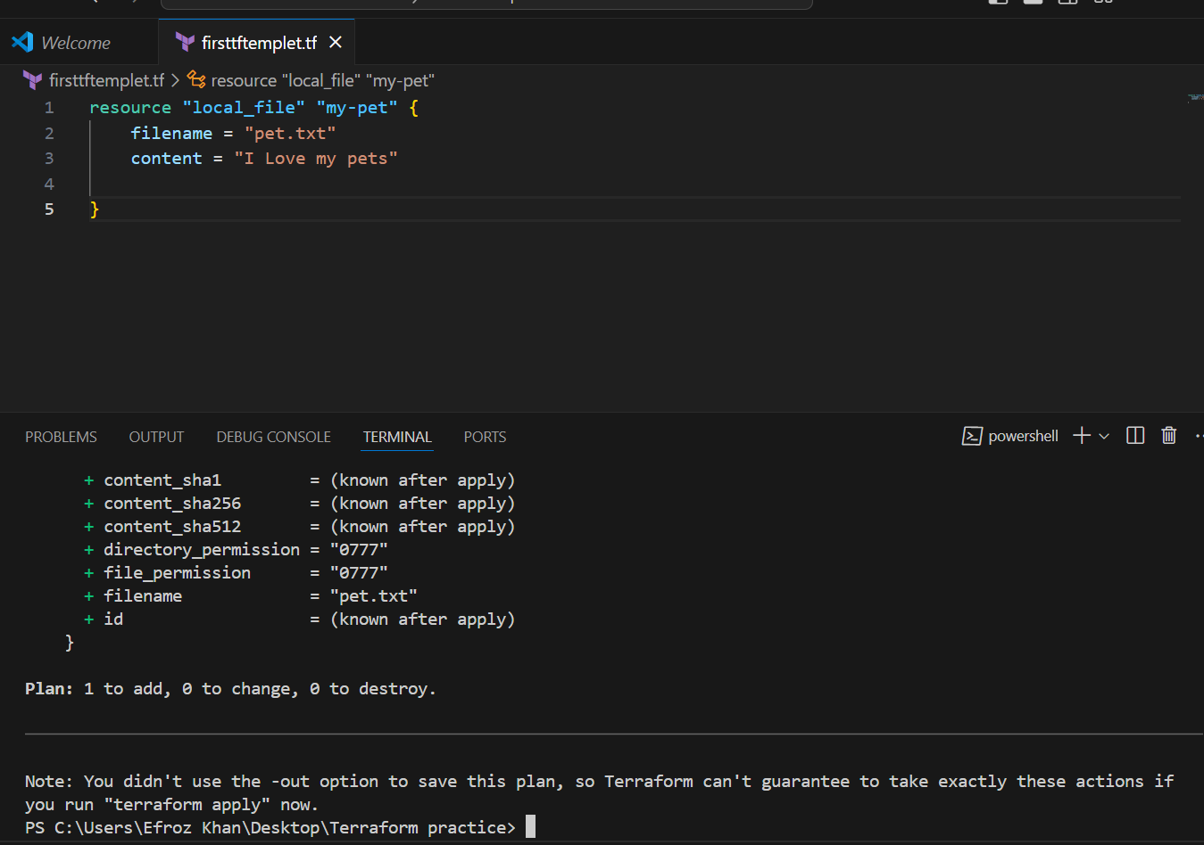

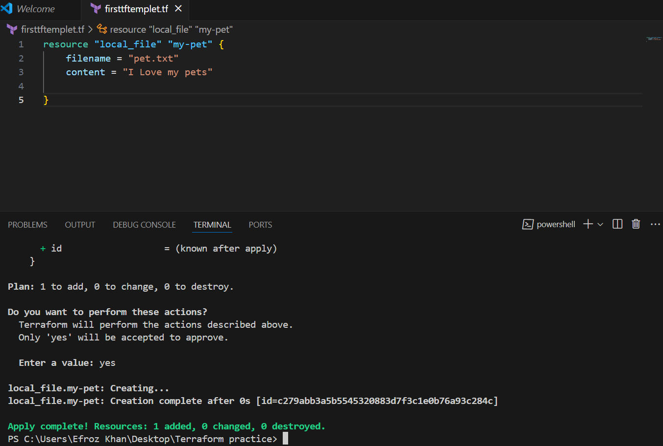

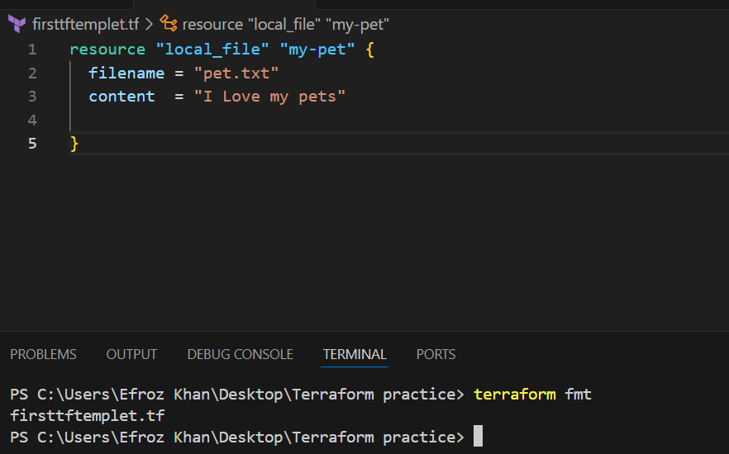

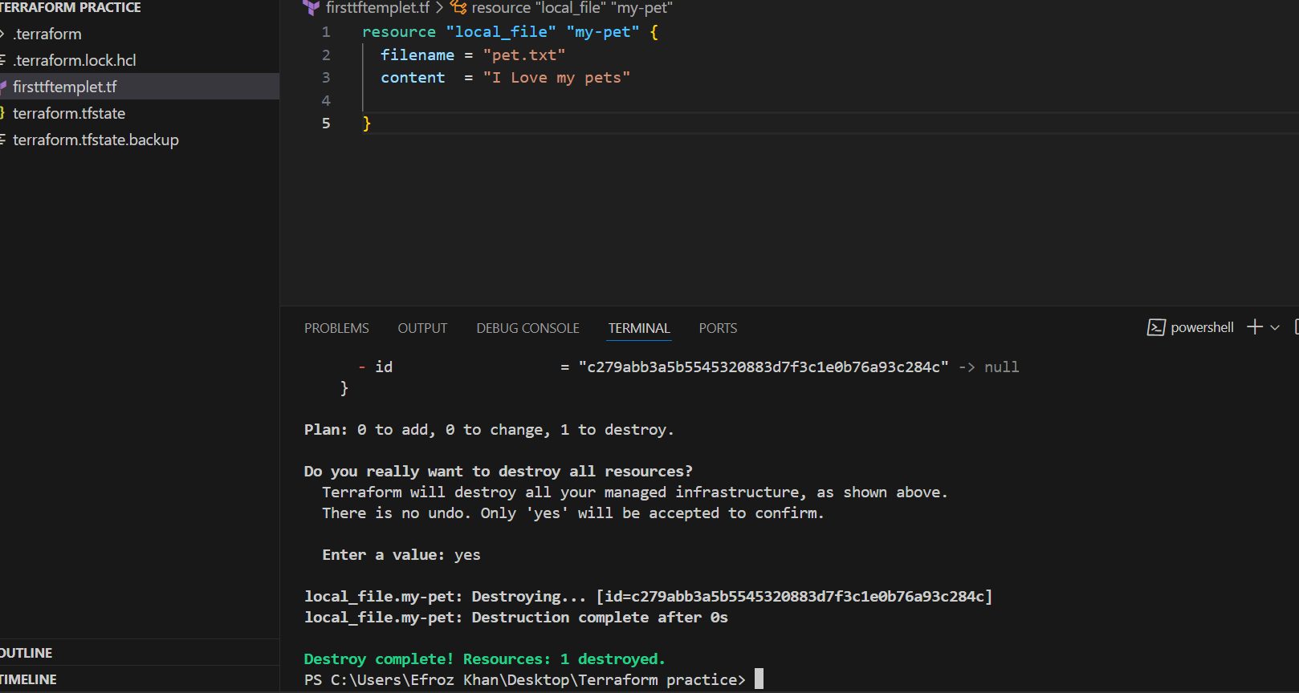

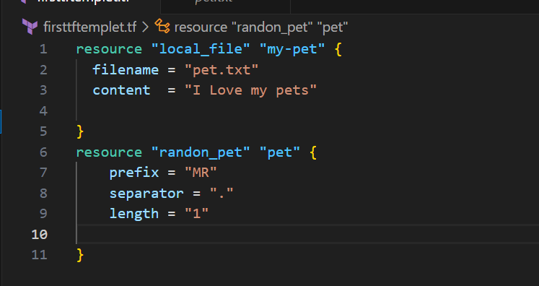

Here in this templete, we added another provider called random provider.

1. Note down below points, Terraform Init Terraform Plan Terraform Apply Terraform
2. Provider.

**Terraform init:**  
to initialize terraform and download the   
dependencies for the resources.  
**Terraform Plan:**  
To dry run or show how terraform will be executing   
the resource file.  
**Terraform Apply:**

To execute and make changes of the resource file.  
**Terraform Provider:**  
It is used to see the list of providers used in   
configuration file

1. Integrate a sample Terraform template in jenkins.
2. Watch the terraform-02 video.

Watched

1. Execute all the templates shown in video.

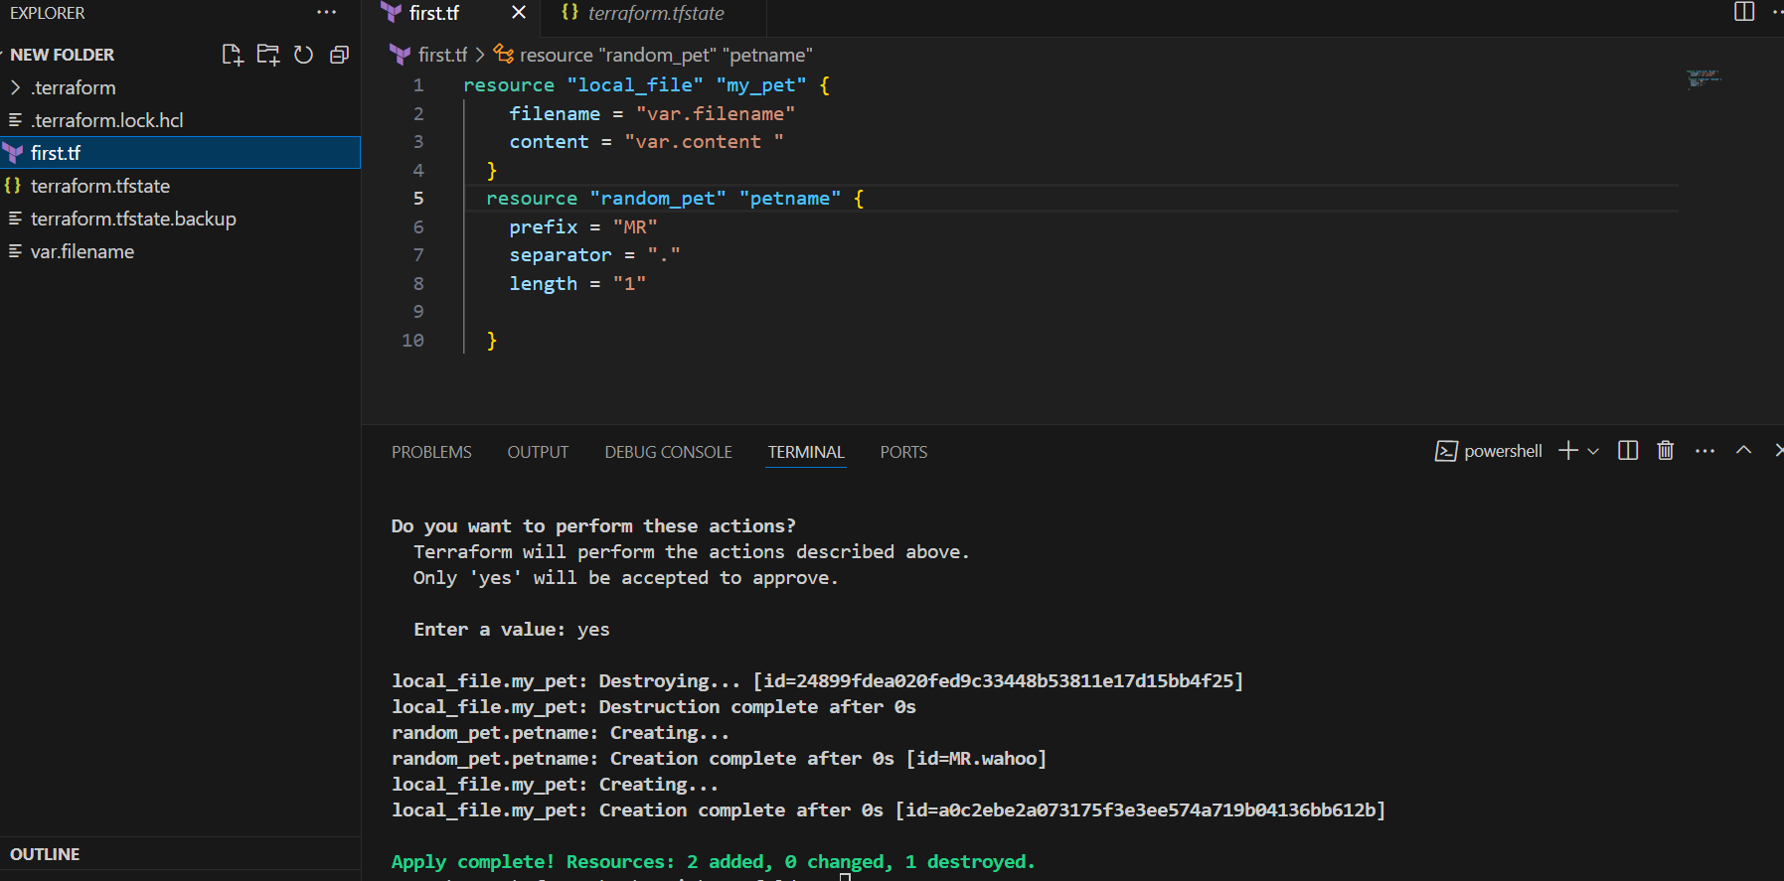

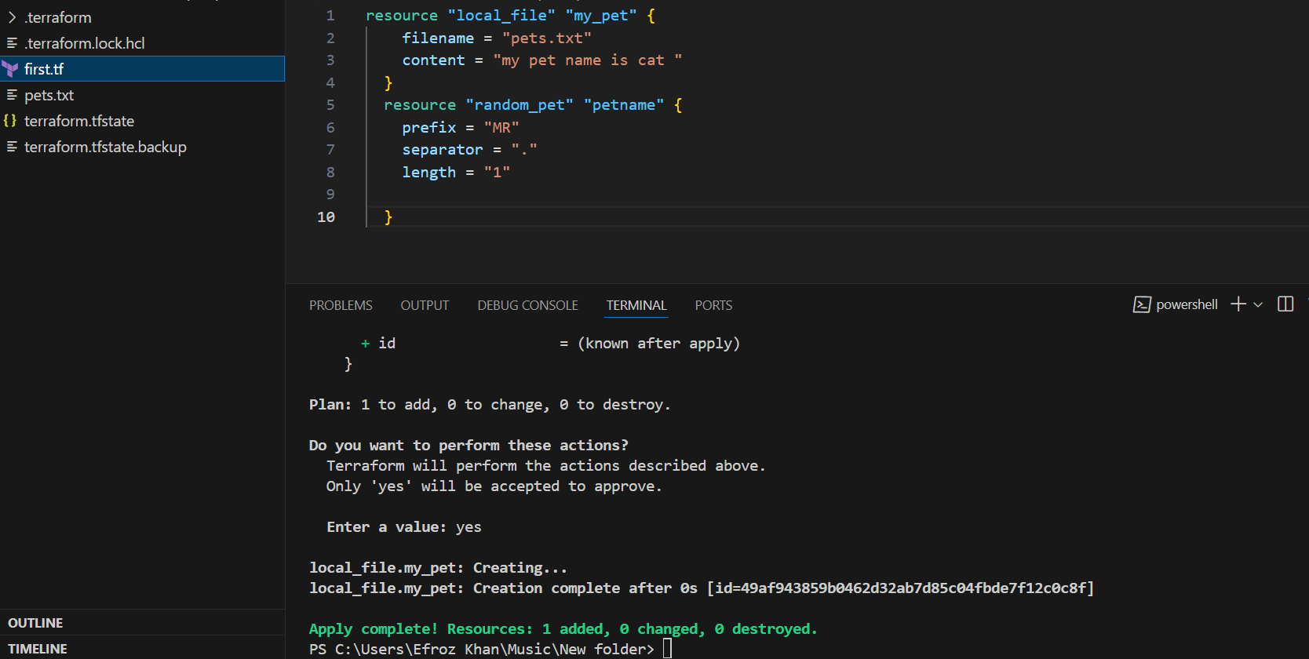

Lifecycle create before destroy Rule:-

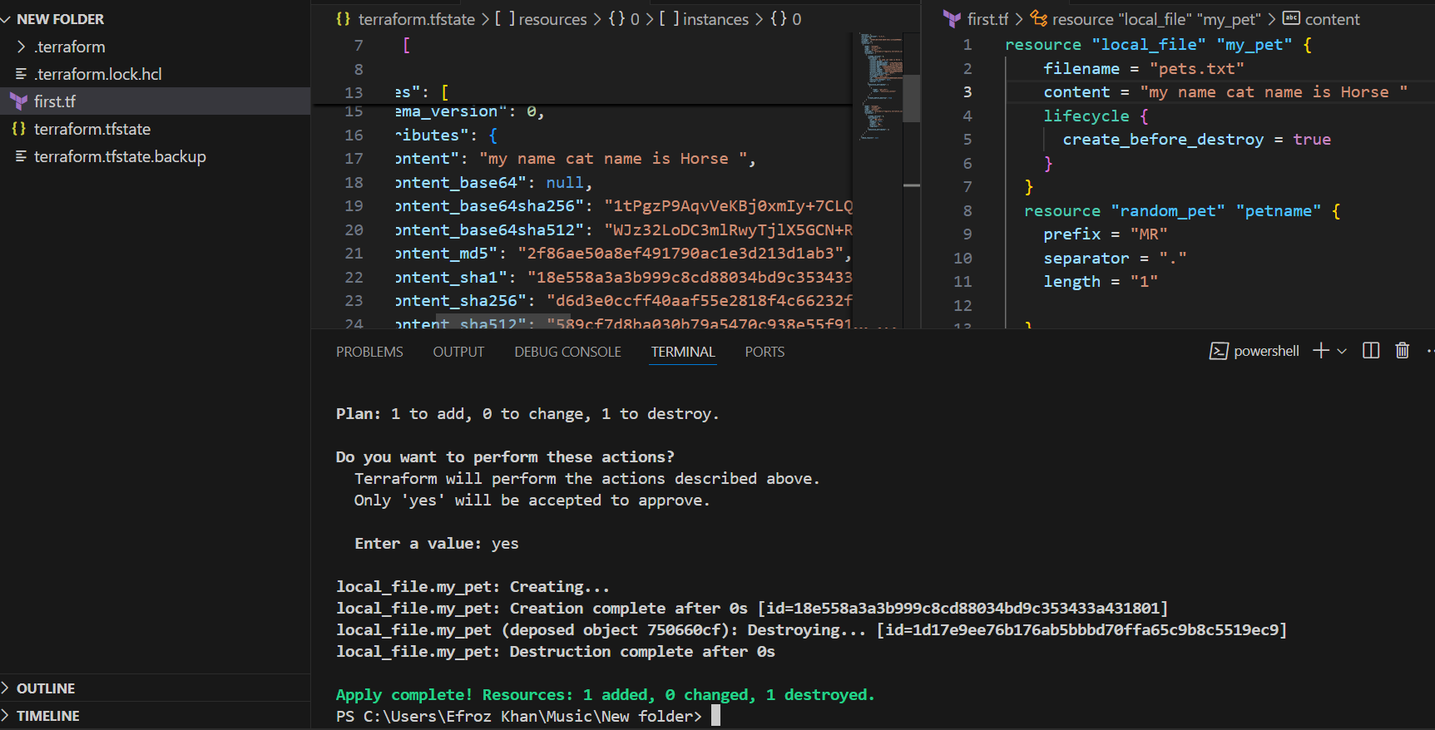

Lifecycle prevent_destroy:-

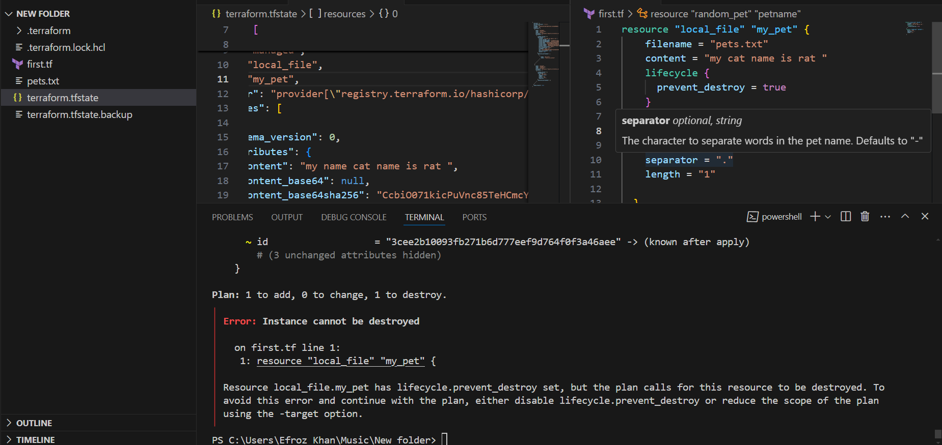

Lifecycle ignore_Changes

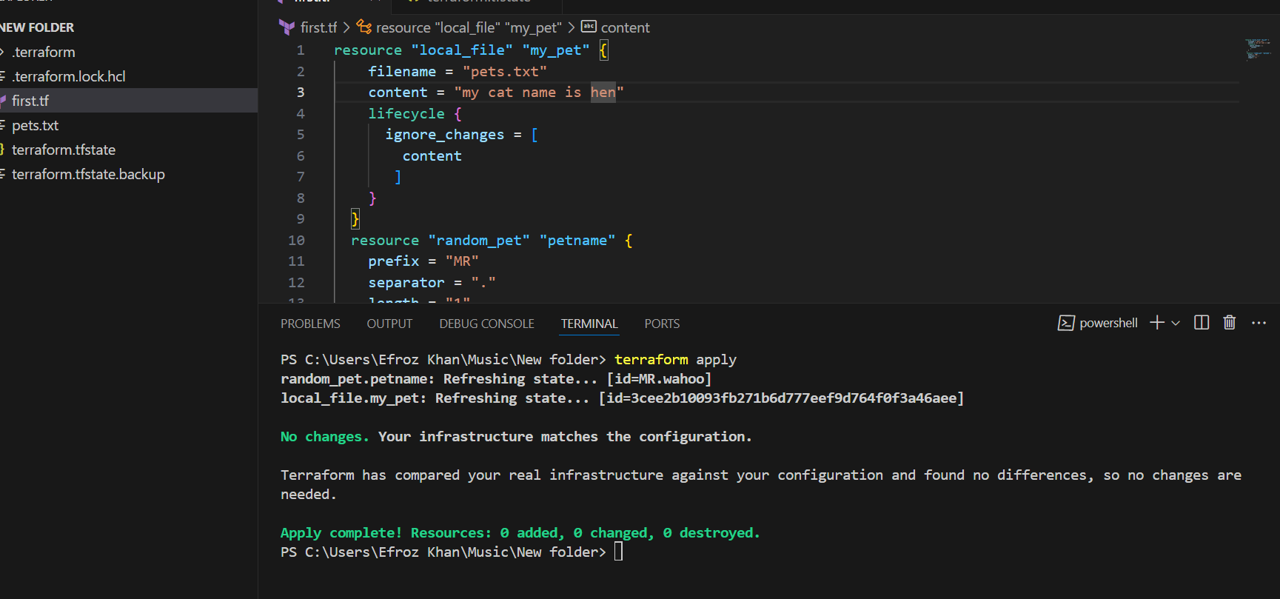

Variable as String:-

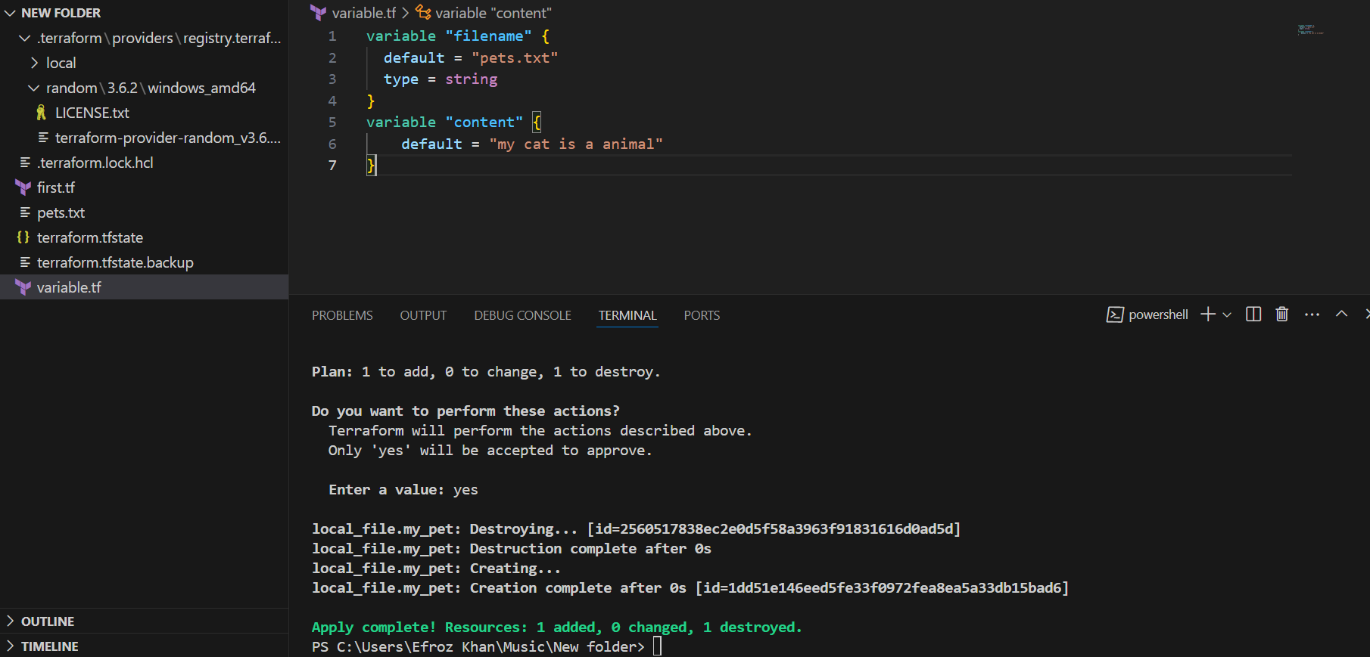

Variable as Number:-

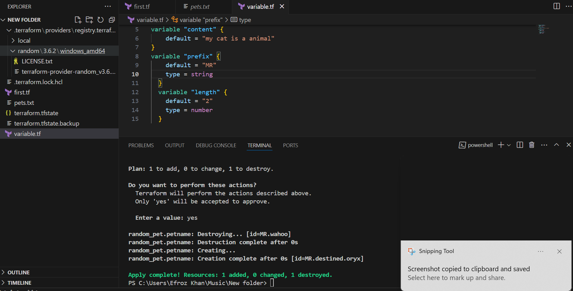

Variables by using variables.tf file (interactive mode variable) : Entering the value at run time of command

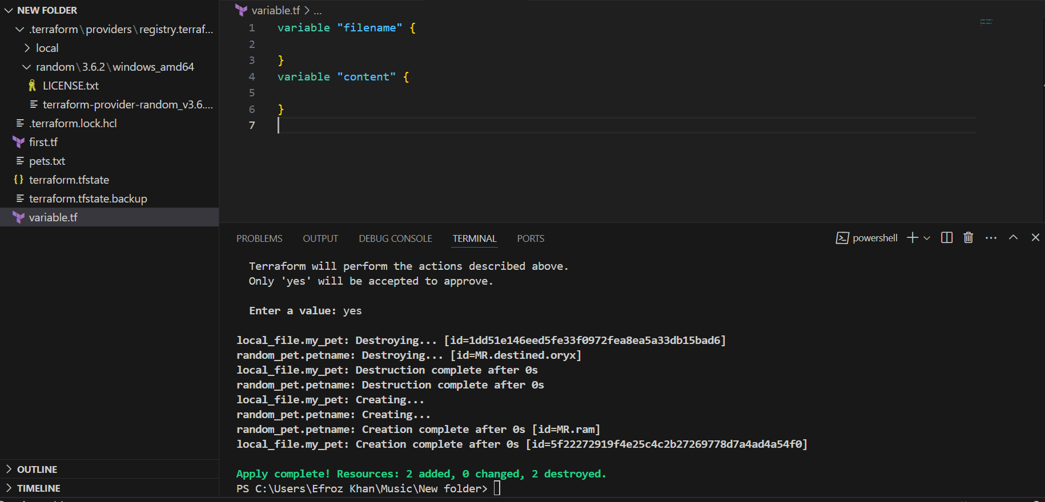

* **Variables by using variables.tf files and passing varible name and contentt the throuth the comman line. (Command line flags)**

**terraform apply -var "filename=wild.txt" -var "content=i love animals"**

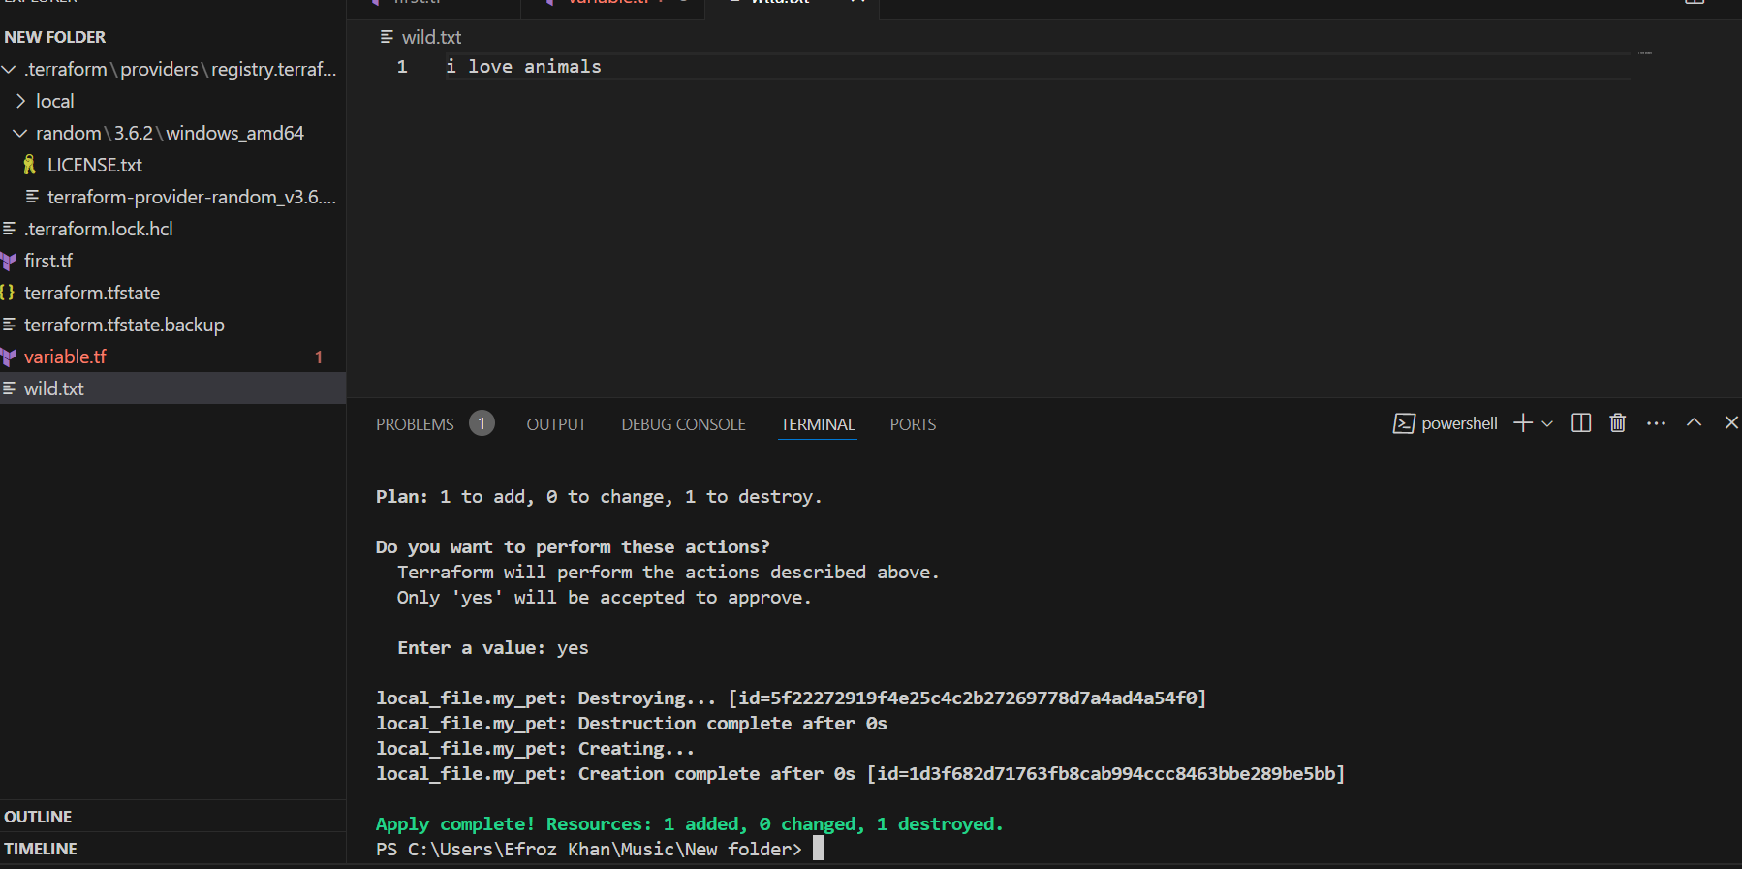

1. Integrate terraform in jenkins using Terraform plugin.